Template for the DS Assignment 2- part 1

Please note that you can modify this template to suit your own presentation

This is only a sample, you should make sure all aspects of your work and assessment tasks are clearly evidenced

You should check Assignment Deliverables and the marking schema.

Take screenshots showing clearly:

- Student id in Apex account
- Apex 5 – university www address
- Time and date on your machine
E.g.
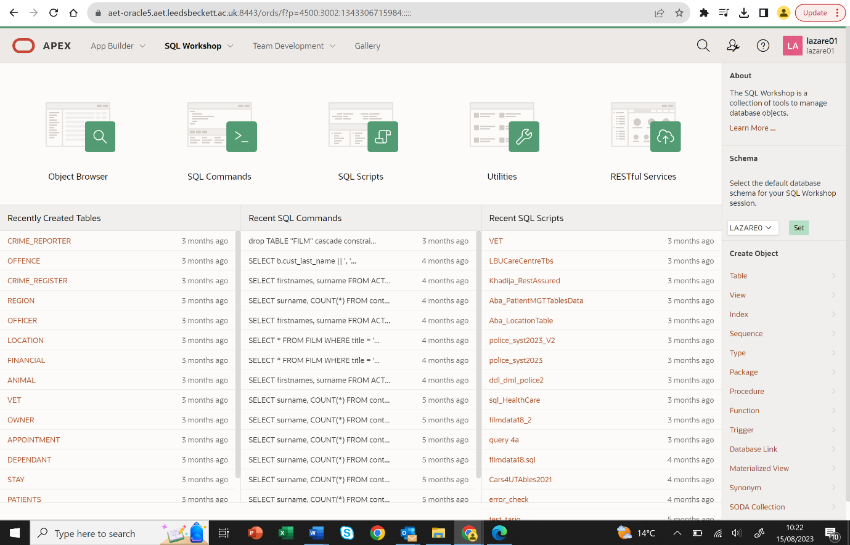
2
1
3

Title:
Module Name:
Student Name:
Student id:

Task 1:
Complete required tutorial tasks and include in this submission. The tasks required are found in Appendix E. USE Tutorial Upload Template 2023 for this task!

Task 2: Implementation of tables, data and view
Clearly show successful run of the code, CLEAERLY SHOWING YOUR STUDENT ID. See above example what each screenshot should include.

Aslo, show clearly your view being created, and how you’ve tested your view.
Screenshot of code running successfully.
Each member has to include screenshot of running it in their own Oracle Apex environment, uploaded as part of the group submission.
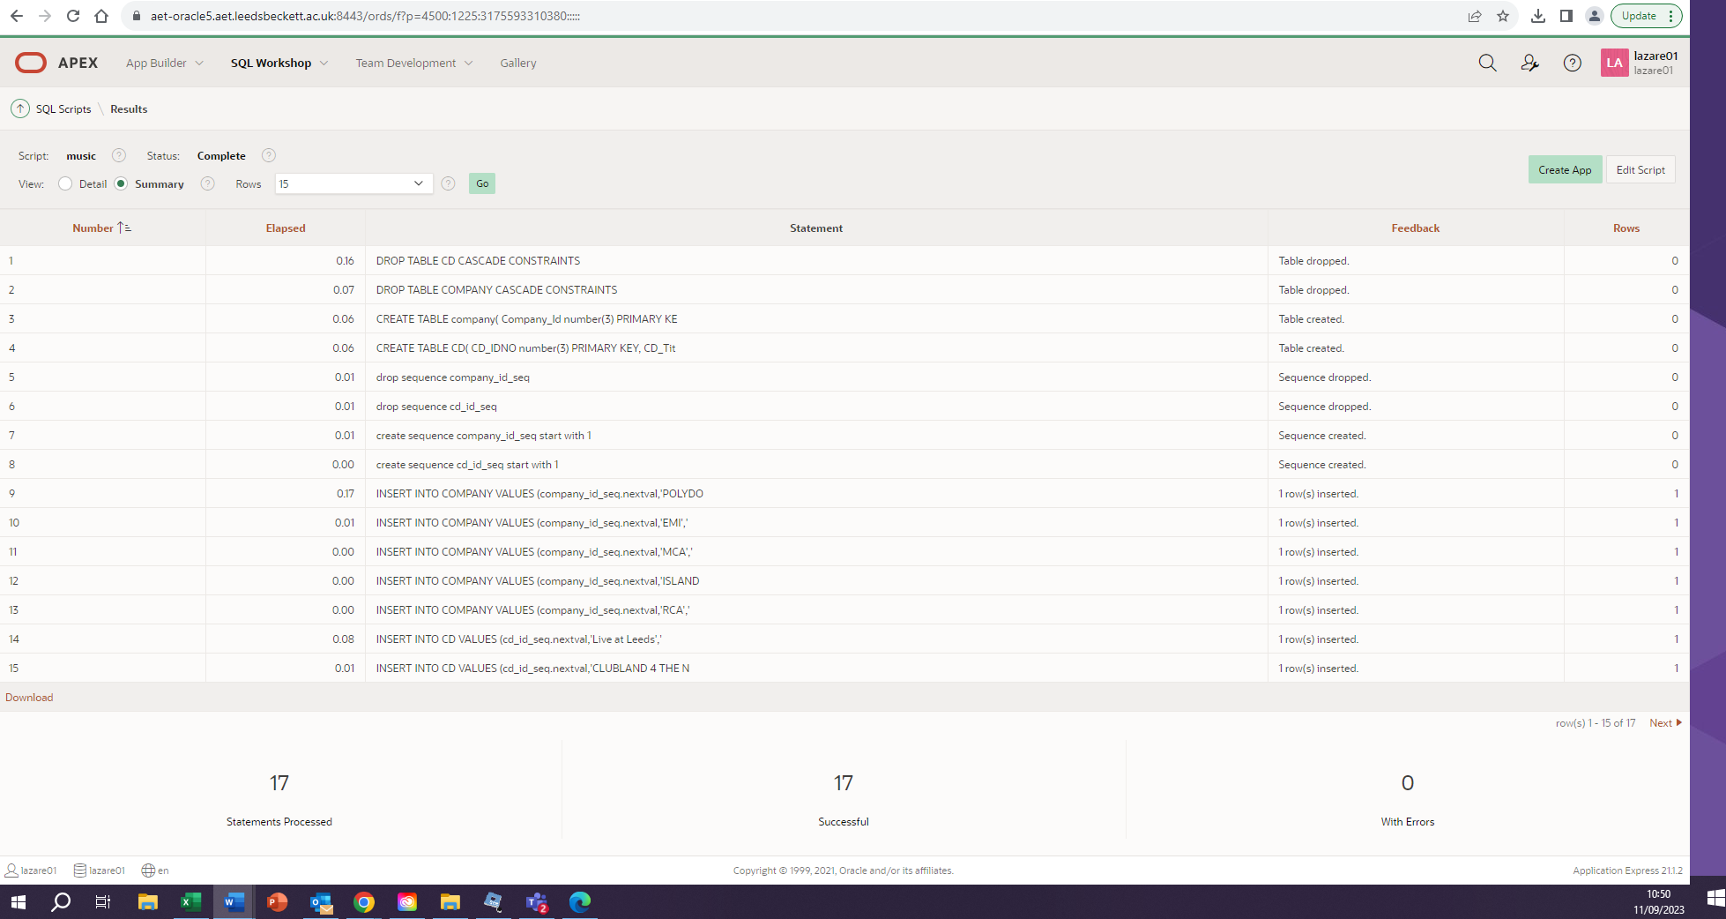
--make sure you run test...
-- evidence screenshots of code running.
-- Also, include scripts code as shown below;

DROP TABLE CD CASCADE CONSTRAINTS;
DROP TABLE COMPANY CASCADE CONSTRAINTS;

CREATE TABLE company(
Company_Id number(3) PRIMARY KEY,
Company_name VARCHAR2 (15) NOT NULL,
Country VARCHAR2 (15) NOT NULL,
Phone_number VARCHAR2 (15) NOT NULL);

CREATE TABLE CD(
CD_IDNO number(3) PRIMARY KEY,
CD_Title varchar2(50) NOT NULL,
CD_Artist varchar2(30) NOT NULL UNIQUE,
CD_Date_Purchased date NOT NULL,
CD_Payment_type varchar2(6) NOT NULL,
CD_Music_category varchar2(10) NOT NULL,
CD_Price number(4,2) CHECK ( cd_price > 0),
Company_Id number(3) references company(Company_Id) ON DELETE CASCADE);

drop sequence company_id_seq;
drop sequence cd_id_seq;

create sequence company_id_seq start with 1;
create sequence cd_id_seq start with 1;

INSERT INTO COMPANY VALUES (company_id_seq.nextval,'POLYDOR','UK','0171 0989099');
INSERT INTO COMPANY VALUES (company_id_seq.nextval,'EMI','UK','0171 0989088');
INSERT INTO COMPANY VALUES (company_id_seq.nextval,'MCA','UK','0171 7789088');

INSERT INTO CD VALUES (cd_id_seq.nextval,'Live at Leeds','The Who','12/12/12','Cash','Rock',10.99,'001');
INSERT INTO CD VALUES (cd_id_seq.nextval,'CLUBLAND 4 THE NIGHT OF YOUR LIFE','VARIOUS','12/12/12','Cash','Club',13.99,'001');
INSERT INTO CD VALUES (cd_id_seq.nextval,'CLUBBERS GUIDE 2004','VARIOUS','04/12/12','Credit','Club',13.99,'003');
INSERT INTO CD VALUES (cd_id_seq.nextval,'THE VERY BEST OF STING AND THE POLICE','The POLICE','12/12/12','Cash','Rock',10.99,'002');

Task 3: Apex Report in Application Builder

1: SQL code and Screen shot of SQL Commands
E.G Business rule: Details on production companies for each artist
SELECT COMPANY_NAME, CD_ARTIST FROM CD, COMPANY WHERE CD.COMPANY_ID = COMPANY.COMPANY_ID

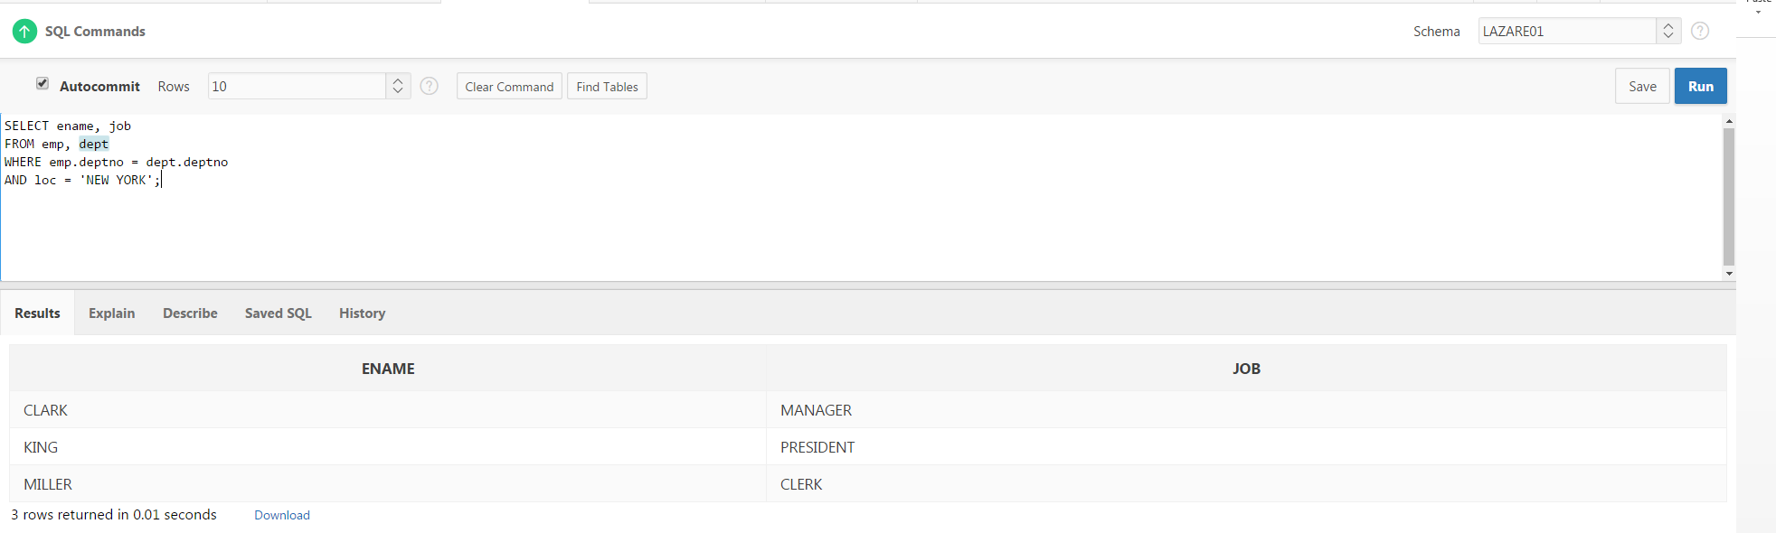

Report view in Application Builder. Note that your screenshot must include what’s specified on page 1.

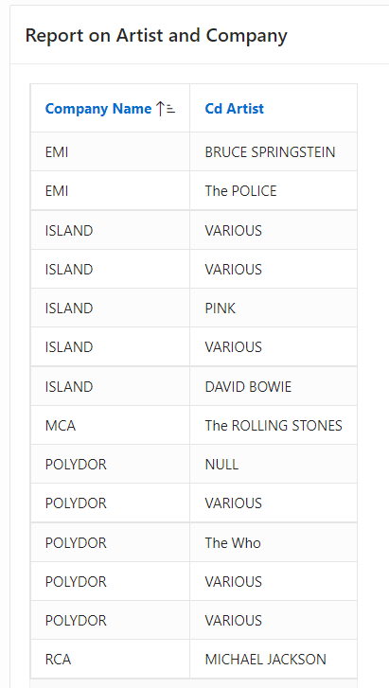

2: SQL code and Screen shot of SQL Commands

3: SQL code and Screen shot of SQL Commands

Etc….

…

Task 4: Triggers
… see assessment guide for the task.
Evidence clearly code running and being tested using PL/SQL code.
Plan and produce either three triggers as a procedural constraint and evidence that you’ve testing code.

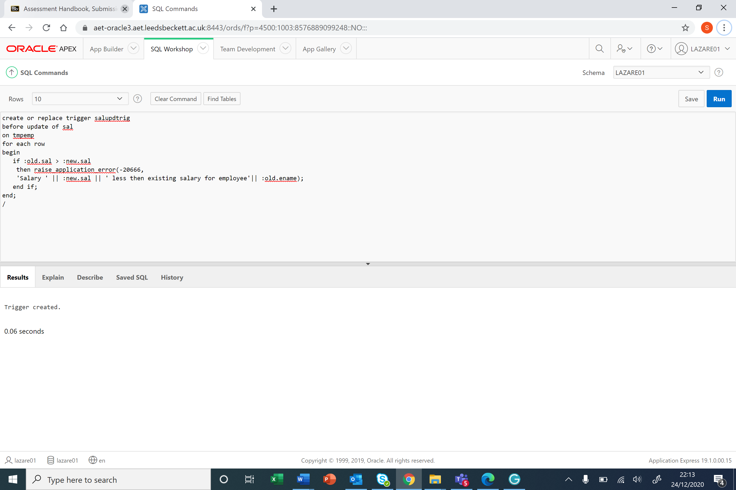

Fire trigger
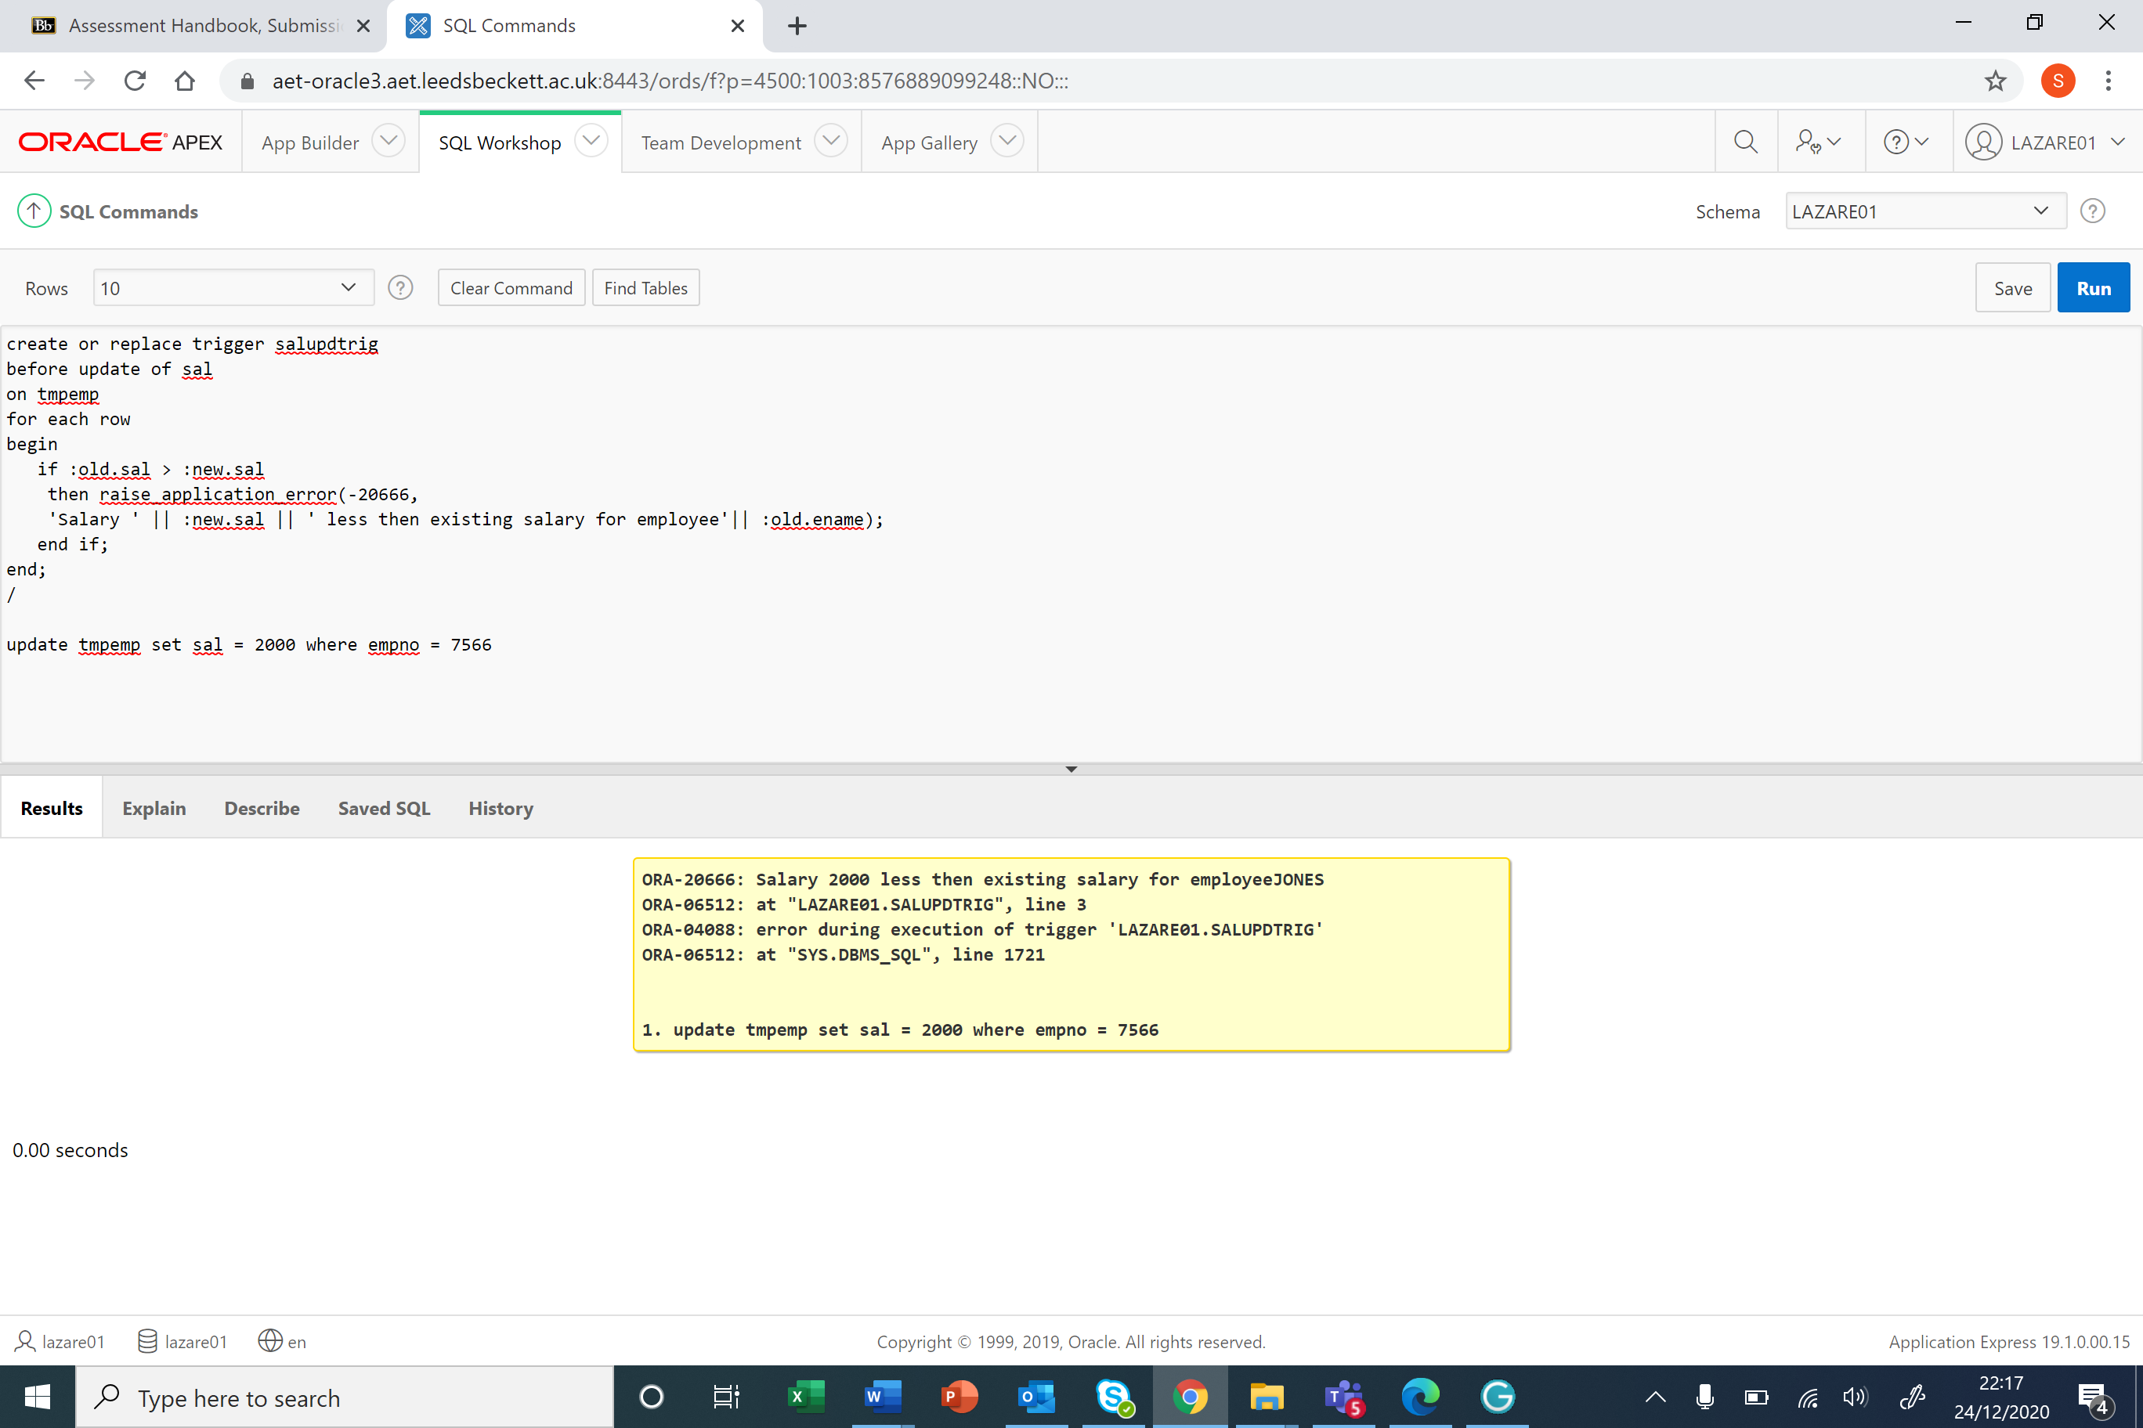

Trigger not fireing
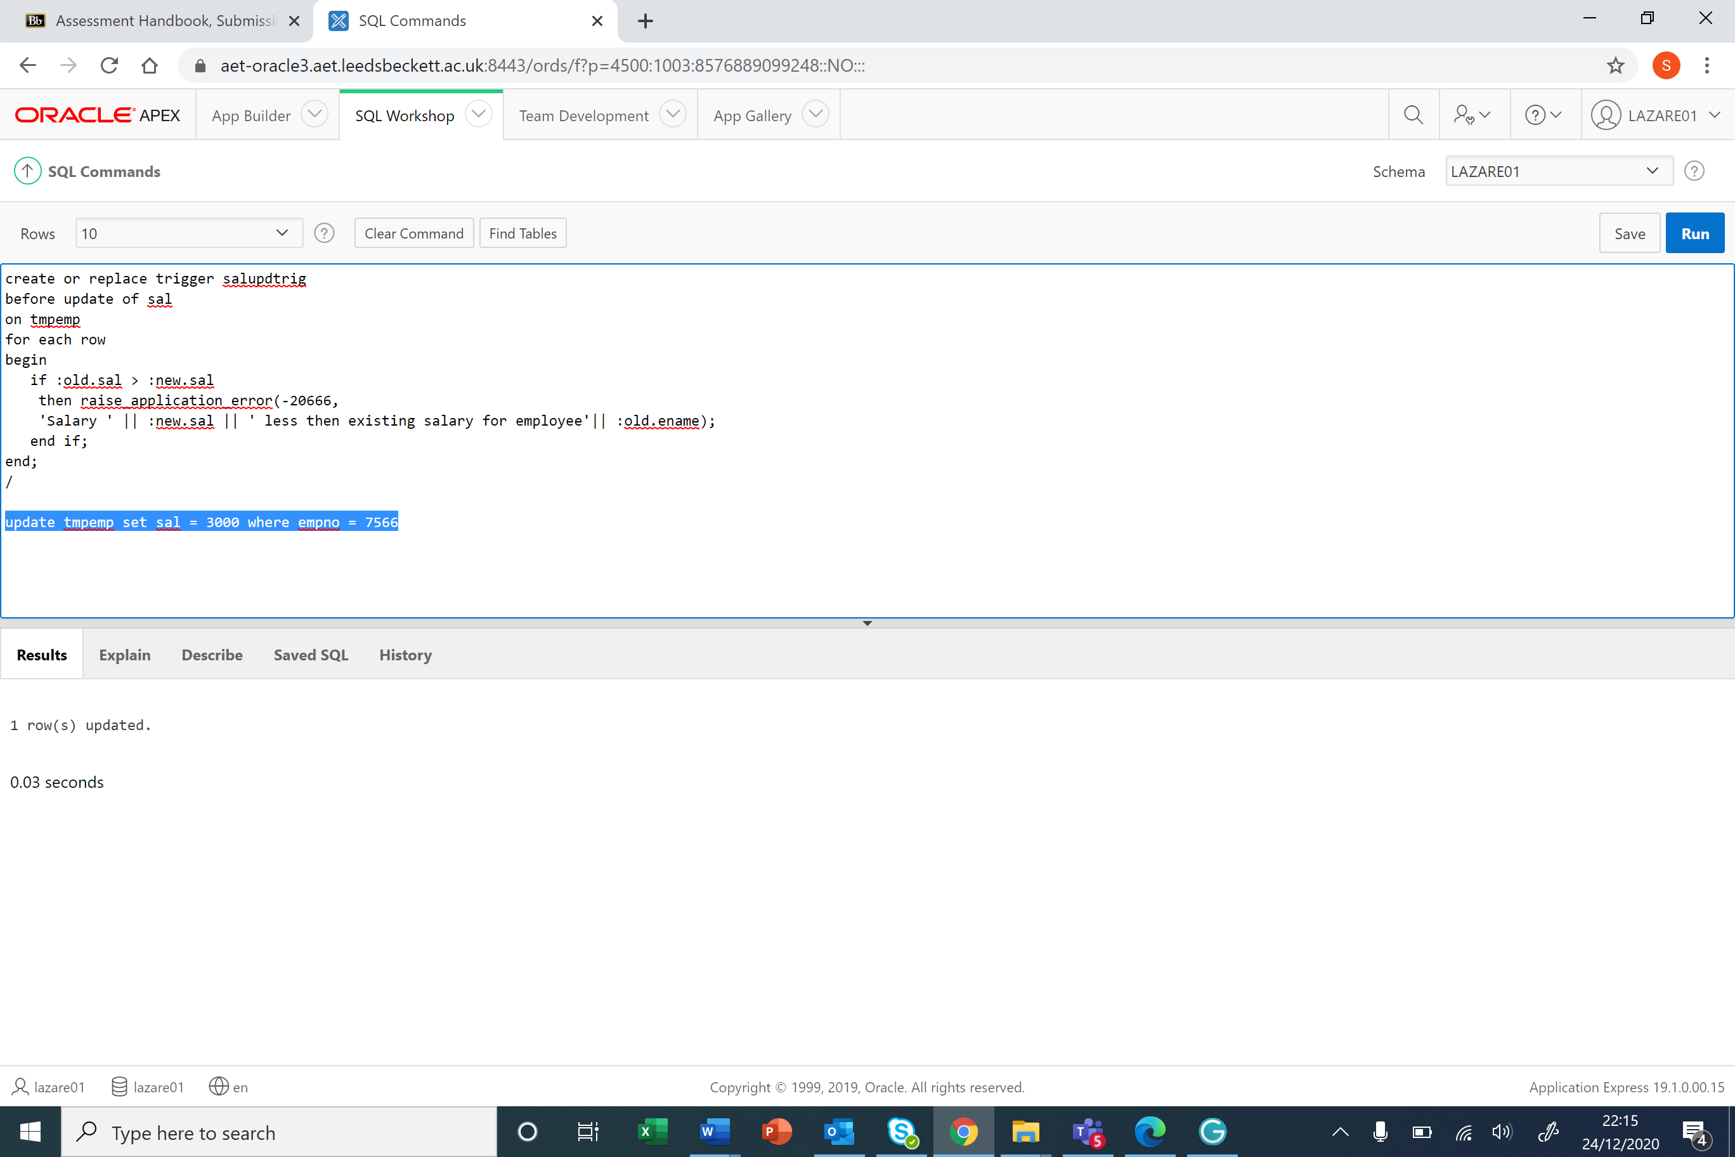

Bibliography

Harvard style

Appendixes
DDL and DML code

